STA 5107 Homework Assignment #6

1. (a)

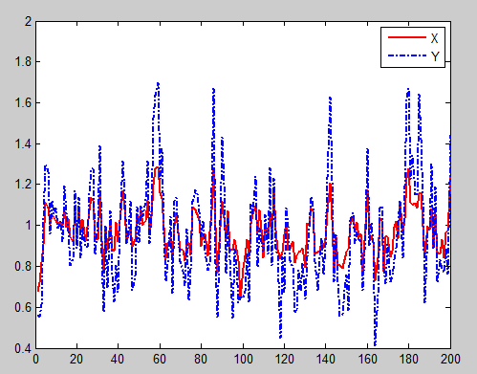

Figure (1) state x and observation y

(b)

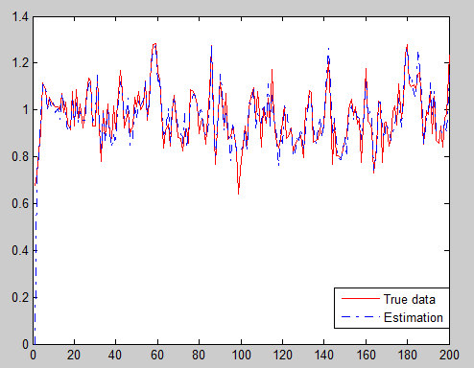

Figure (2) True and Estimation (using posterior mean)

We get the R^2 = 0.8225

(c)

The Kolmogorov_Smirno test indicates that all the four posterior are normal distributions. The histograms are:

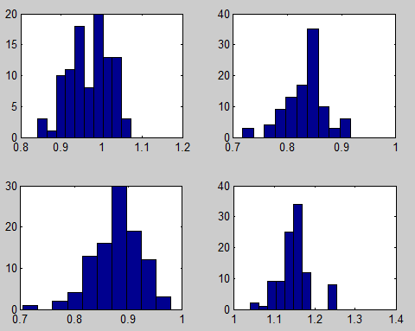

Figure(3) Posterior at times 50 100 150 and 200

Test Result:

h =

0 0 0 0

Matlab Program:

%solution for HM 6

% Problem 1

close all;

clear all;

N = 200;

x(1) = rand(1);

%sample from V

tmpv = 0.1*randn(1);

y(1) = x(1)^2 + tmpv;

for i = 2:N

%sample for ut

tmp = 0.1*randn(1);

x(i) = sqrt(abs(x(i-1)))+tmp;

tmpv = 0.1*randn(1);

y(i) = x(i)^2 + tmpv;

end;

%display xt and yt;

plot(x,'r','LineWidth',2);

hold on, plot(y,'-.','LineWidth',2);

%for part b

% for function g

g = inline('x','x');

%generate one hundred samples

x_e(1,:) = rand(1,100);

for i=2:N

%generate the prediction

tmp = 0.1*randn(1,100);

x_tilte(i,:) = sqrt(abs(x_e(i-1)))+tmp;

%compute the weights

tmpv = 0.1*randn(1,100);

%w(i,:) = x_tilte(i,:).^2 + tmpv;

%normalize the weight;

w(i,:) = normpdf(y(i),x_tilte(i,:).^2,0.1);

w_n(i,:) = w(i,:)/sum(w(i,:));

W_n(i,:) = cumsum(w_n(i,:));

%estimate theta

theta_hat(i,:) = sum(w_n(i,:).*x_tilte(i,:));

%resample

for t = 1:100

U = rand;

ind = find(U-W_n(i,:)<0);

x_e(i,t) = x_tilte(i,ind(1));

end;

% xx(i,:) = sum(w_n(i,:).*g(x_e(i,:)))

end;

%plot the estimation

figure(2);

%subplot(2,1,1)

plot(1:200,x,'r-')

hold on, plot(1:200,theta_hat,'-.');

%hold on, plot(1:200,x,'r-.');

%compute the R^2

X_r = theta_hat(11:200)';

M_X = mean(X_r);

R_X= 1-sum((x(11:200)-X_r).^2)/sum((x(11:200)-M_X).^2);

%plot the histogram of the values

figure(3),

subplot(2,2,1);

hist(x_e(50,:));

%standardized the data

temp_x = x_e(50,:);

temp_x = temp_x-mean(temp_x);

temp_x = temp_x/sqrt(var(temp_x));

h(1) = kstest(temp_x);

subplot(2,2,2);

hist(x_e(100,:));

temp_x = x_e(100,:);

temp_x = temp_x-mean(temp_x);

temp_x = temp_x/sqrt(var(temp_x));

h(2) = kstest(temp_x);

subplot(2,2,3);

hist(x_e(150,:));

temp_x = x_e(150,:);

temp_x = temp_x-mean(temp_x);

temp_x = temp_x/sqrt(var(temp_x));

h(3) = kstest(temp_x);

subplot(2,2,4);

hist(x_e(200,:));

temp_x = x_e(200,:);

temp_x = temp_x-mean(temp_x);

temp_x = temp_x/sqrt(var(temp_x));

h(4) = kstest(temp_x);

Probem 2.

(a)

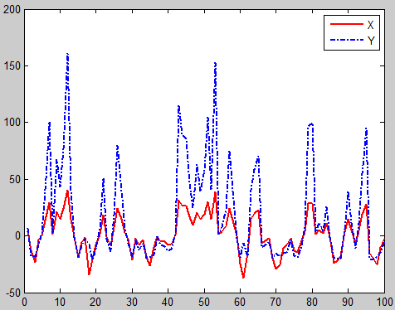

Figure (4) state x and observation y

(b)

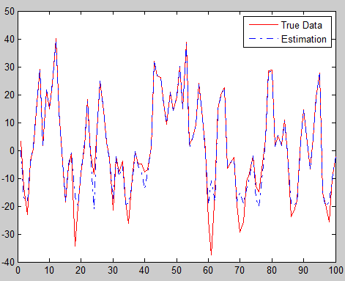

Figure (2) True and Estimation (using posterior mean)

We get the R^2 = 0.9273

(c)

The Kolmogorov_Smirno test indicates that all the four posterior are not normal distributions. The histograms are:

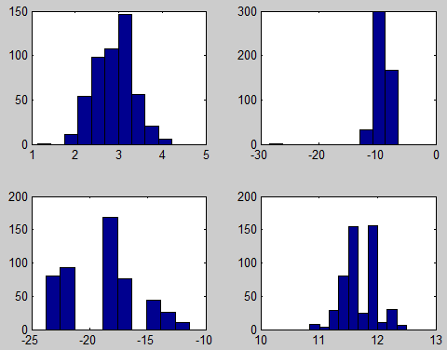

Figure(3) Posterior at times 25 50 75 and 100

Test Result:

h =

1 1 1 1

Matlab Code: